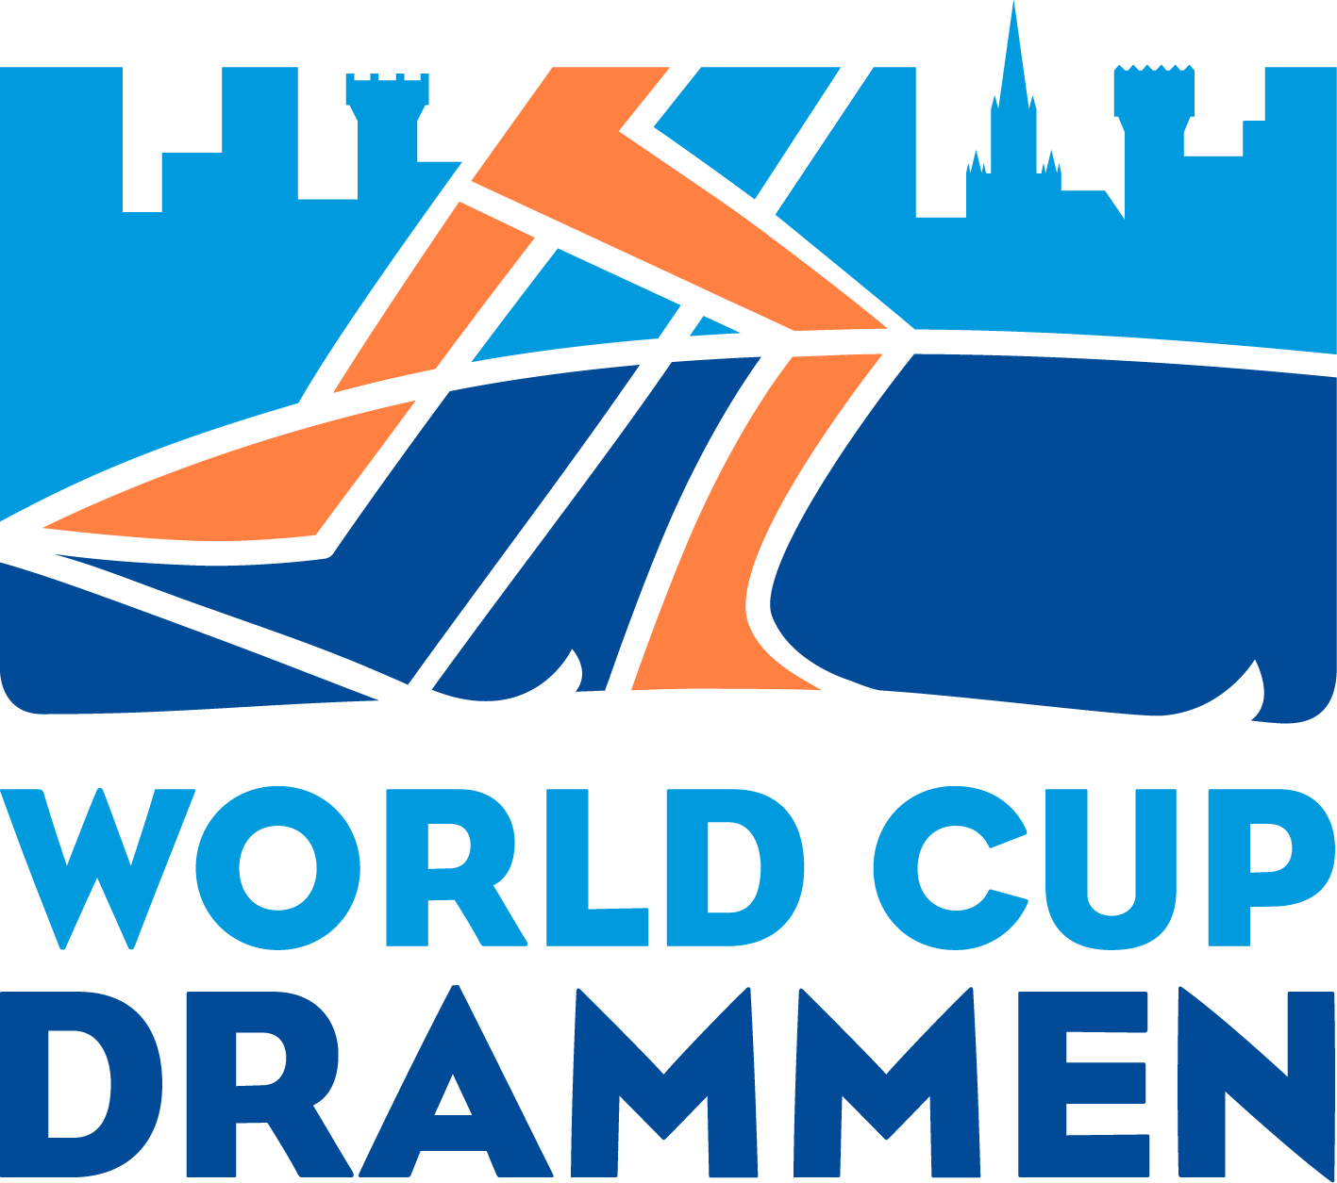

International media invitation
FIS World Cup Drammen- March 3.- 2022

FIS and the organizing committee for the World Cup Drammen, a collaborative project between IL Konnerud as the technical organizer, the municipality of Drammen and "Byen Vår Drammen", welcomes you to FIS World Cup Drammen 2022 – a classic style sprint race in the city center of Drammen.

The program for this year's race will be:

Tuesday March 03. 2022
Start sprint prologue 10.00
Start sprint finals 12.30
Flower- and Prize Ceremony will be held asap after the race – about 14.00

Accreditation for journalists and photographers:
The accreditation will be subject to the FIS regulations.
For application please send this requested information:

Name: AIPS/National press organisation number:
Mobile phone:
E-mail: Name of media organization – if freelance who are your clients:
Function (journalist OR photograph):
Parking (see further info later on):
Send to acting press officer: Johan Fredrik Høvås - johanfredrikhovas@gmail.com

The deadline for applications is February 26.- 2022.

Accreditation in general: Only professional photographers/journalists can expect accreditation. The OC reserves right to reject accreditations that not satisfies this.
Due to the covid situation and the experience with limited space in the finish area, we will this year need to be more restrictive. LOC reserves the right to refuse accreditations that do not meet the requirements and no accreditation is approved until it is confirmed.
Accreditation and covid restrictions: LOC follow FIS’ latest updated covid protocol, which at the time of writing states that everyone who is to be accredited must be able to present a valid corona certificate. For media, only journalists who need to be in the Mixed-Zone, and photographers, can access what is defined the "Red Bubble", while others in the media have access to the press centre - if this is in accordance with the FIS’ covid protocol.

It must therefore be specified whether you apply for accreditation as a Mixed-Zone-jornalist and photographer and thus want access to "Red Bubble". The MZ-journalist and photographer in question must then personally pick up their accreditation at the accreditation centre at the Scandic Ambassadeur Hotel - Strømsø Torg 7, 3044 Drammen - Tuesday, Wednesday, or Thursday morning.

At the accreditation centre you must present a corona passport and present a negative PCR test taken a maximum of 48 hours before accreditation, in order to be awarded "red bubble" accreditation, and the photograpers can then pick up a photo vest at the press centre in Bragernes Menighetshus - Kirkegata 7, 3016 Drammen (to the left of the church) - against a deposit of press card or similar.
Everyone else in the media picks up their accreditations, against presenting a valid corona certificate, at the same accreditation centre at the Scandic Ambassadeur Hotel - Strømsø Torg 7, 3044 Drammen - Tuesday, Wednesday, or Thursday morning.

Accreditation for TV, radio and internet in Norway will be authorized by Ola Fagerheim and Yngvill Imerslund
+47 959 22 217 / + 47 907 85 746 ola.fagerheim@nrk.no / yngvill.imerslund@nrk.no
International TV, radio, production and internet companies will be authorized by Infront Italy. They will have to submit their requests to film or commentate on-site directly to Infront Italy’s TV & Media Rights contact: Alexander Emde +39 335 654 94 34 Alexander.Emde@infrontsports.com
Accommodation for media
For all questions regarding accommodation for media please contact: Anne Grete Trydal +47 419 05 554 atrydal@hotmail.com

Press Centre (MPC)
NEW location in 2022 !!
Bragernes Menighetshus - Kirkegata 7, 3016 Drammen (to the left of the church) This is very close to the finish area. The MPC will be open: March 3 : 09:00-18:00 TBC
Acting press officer: Johan Fredrik Høvås- 90144270 - johanfredrikhovas@gmail.com

Press Conferences
Information regarding national team press conferences will be published on our website. There will be no press conferences after the race.

Photo Briefing
There will be a photo briefing for all accreditated photographs in front of the race. Further info will follow. Chief of Photo is Børre Erik Helgerud- 95295477.

Parking
TBC - but please request in the apply for accreditation if you need so.

Transportation: Use the train
We recommend all media to use the train to attend this event. The Airport Shuttle (Flytoget) brings you from Oslo Airport Gardermoen to Drammen in about one hour time. (See www.flytoget.no ).

You can also use the ordinary train service. From Oslo either from Oslo S (Oslo Central Station) or Nationalteateret (The National Theather Station). For further info see www.nsb.no or contact us for help.

If you have questions; Please contact acting press officer: Johan Fredrik Høvås 90144270 - johanfredrikhovas@gmail.com

For further info visit: https://worldcupdrammen.no/

